Python OOP Retake Exam - 18 December 2024

Flower Shop

At Petal & Leaf Floral Boutique the plants found their way into loving homes, embodying the beauty of nature and the joy of nurturing life. The shop flourished, reflecting the harmonious connection between people and the environment, as each purchase marked a new beginning for both plant and owner.

Note: You are not allowed to change the folder and file structure and their names!
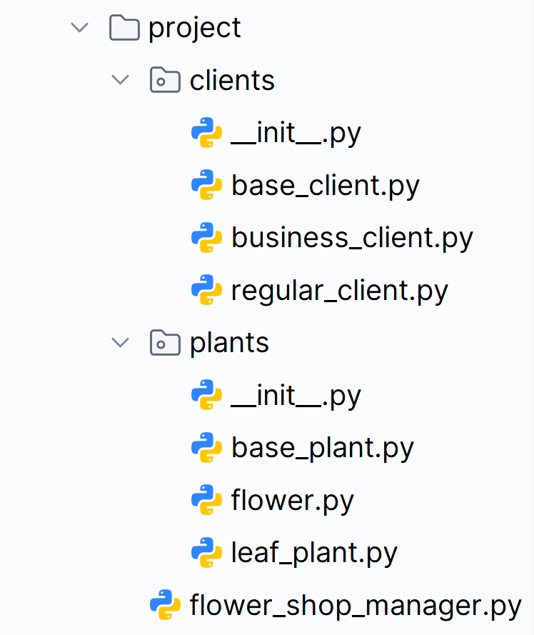

Judge Upload
For the first two problems, create a zip file with the project folder and upload it to the judge system.
For the last problem, create a zip file with the test folder and upload it to the judge system.
You do not need to include your venv, .idea, pycache, and __MACOSX (for Mac users) in the zip file, so you do not exceed the maximum allowed size of 16.00 KB.

Structure (Problem 1) and Functionality (Problem 2)
Your task is to implement all the classes' structure and functionality (properties, methods, inheritance, abstraction, etc.)
You are free to add additional attributes (instance attributes, class attributes, methods, dunder methods, etc.) to simplify your code and increase readability if it does not change the project's final result under its requirements so that the program works properly.

Class BasePlant
In the base_plant.py file, the class BasePlant should be implemented. It is a base class for any type of plant, and it should not be able to be instantiated.

Structure
The class should have the following attributes:
- name: str
  - The value represents the name of the plant.
  - If the name is an empty string or contains only white spaces, raise a ValueError with the message: "Plant name cannot be null or empty!"
- price: float
  - Represents the price of each plant.
  - If the price of the plant is equal to or less than 0.0, raise a ValueError with the message: "Price must be greater than zero!"
- water_needed: int
  - Represents the amount of water needed in ml.
  - Must be between 1 and 2000, both inclusive. If not, raise a ValueError with the message: "Water needed must be between 1 and 2000 ml!"

Methods

__init__(name: str, price: float, water_needed: int)
- In the __init__ method, all the needed attributes must be set.

plant_details()
- A method that provides information for each plant.
- Remember that each plant type can implement the method differently.

Class Flower
In the flower.py file, the class Flower should be implemented. Flowers are a type of plant.

Methods

__init__(name: str, price: float, water_needed: int, blooming_season: str)
- In the __init__ method, all the needed attributes must be set.
- blooming_season: str
  - Represents the season when the flower blooms.
  - Valid seasons are: "Spring", "Summer", "Fall", and "Winter".
  - If the blooming season is not one of the valid ones, raise a ValueError with the message: "Blooming season must be a valid one!"

plant_details()
- Provides information about the Flower plants in the following format:
  - The price should be formatted to the second decimal place.
"Flower: {name}, Price: {price}, Watering: {water_needed}ml, Blooming Season: {blooming_season}"

Class LeafPlant
In the leaf_plant.py file, the class LeafPlant should be implemented. Leaf plants are a type of plant.

Methods

__init__(name: str, price: float, water_needed: int, size: str)
- In the __init__ method, all the needed attributes must be set.
- size: str
  - Represents the size of the leaf plant.
  - Valid sizes are: "S", "M", and "L".
  - If the size is not one of the valid ones, raise a ValueError with the message: "Size must be a valid one!"

plant_details()
- Provides information about the Leaf plants in the following format:
  - The price should be formatted to the second decimal place.
"Leaf Plant: {name}, Price: {price}, Watering: {water_needed}ml, Size: {size}"

Class BaseClient
In the base_client.py file, the class BaseClient should be implemented. It is a base class for any type of client, and it should not be able to be instantiated.

Structure
The class should have the following attributes:
- name: str
  - The value represents the name of the client.
  - The name must be at least 2 characters long. The name can contain whitespaces, but leading or trailing whitespaces are not counted as characters, so only whitespaces are not allowed either. If the name is invalid, raise a ValueError with the following message: "Name must be at least two characters long!"
- phone_number: str
  - Represents the phone number of the client.
  - The phone number can contain only digits, if not, raise a ValueError with the message: "Phone number can contain only digits!"
- discount: float
  - Represents the discount in percentage (%) each client gets.
  - Initially set to 0.0.
- total_orders: int
  - Represents the total number of client's orders.
  - Initially set to 0.

Methods

__init__(name: str, phone_number: str)
- In the __init__ method, all the needed attributes must be set.

update_discount()
- Sets the discount to a certain percentage, depending on the client's type and number of orders.
- Remember that each client type can implement the method differently.

update_total_orders()
- Increases the client's total orders by 1.

client_details()
- Returns a string with information about the client in the format given below:
  - The discount should be rounded to the smaller integer.
"Client: {name}, Phone number: {phone_number}, Orders count: {total_orders}, Discount: {discount}%"

Class RegularClient
In the regular_client.py file, the class RegularClient should be implemented. The regular client is a type of client.

Methods

__init__(name: str, phone_number: str)
- In the __init__ method, all the needed attributes must be set.

update_discount()
- The method updates the discount as follows:
  - If the client has 1 or more orders, the discount percentage shall be set to 5.0%, otherwise it remains 0.0%.

Class BusinessClient
In the business_client.py file, the class BusinessClient should be implemented. The business client is a type of client.

Methods

__init__(name: str, phone_number: str)
- In the __init__ method, all the needed attributes must be set.

update_discount()
- The method updates the discount as follows:
  - If the client has 2 or more orders, the discount percentage shall be set to 10.0%, otherwise it remains 0.0%.

Class FlowerShopManager
In the flower_shop_manager.py file, the class FlowerShopManager should be implemented. It will contain the functionality of the project.

Structure
The class should have the following attributes:
- income: float
  - Initially set to 0.0.
- plants: list
  - Initially an empty list to store all plants objects the shop has.
- clients: list
  - Initially an empty list to store all clients objects the shop has.

Methods

__init__()
- In the __init__ method, all the needed attributes must be set.

add_plant(plant_type: str, plant_name: str, plant_price: float, plant_water_needed: int, plant_extra_data: str)
The method creates (upon certain conditions) a plant of the given type and adds it to the plants collection:
- First, check if the plant type is valid, and if not, raise a ValueError with the following message: "Unknown plant type!"
- If the type is valid, create and add the plant to the plants collection. Return the following message: "{plant_name} is added to the shop as {plant_type}."
  - Valid types of plants are: "Flower" and "LeafPlant".
  - Plant extra data will always be valid and contain additional information like blooming season or plant size.

add_client(client_type: str, client_name: str, client_phone_number: str)
The method creates (upon certain conditions) a client of the given type and adds it to the clients collection:
- First, check if the client type is valid, and if not, raise a ValueError with the following message: "Unknown client type!"
- Then, check if a client with the same phone number is already added to the list regardless of their type, do not duplicate phone numbers, and raise a ValueError with the following message: "This phone number has been used!"
- If none of the above cases is reached, create and add the client to the clients collection. Return the following message:
"{client_name} is successfully added as a {client_type}."
- Valid types of clients are: "RegularClient" and "BusinessClient".

sell_plants(client_phone_number: str, plant_name: str, plant_quantity: int)
The method performs a sale upon certain conditions. A client with the given phone number purchases plants with the given name and quantity (one or more pieces), if all pre-defined conditions are met:
- First, check if such a client exists:
  - Validate a client's existence with such phone number in the collection of added clients.
  - If no client is found, the method raises a ValueError with the following message:
"Client not found!"
- Then, check if there are plants with this name:
  - Validate the existence of plants with the given name in the collection of plants.
  - If no plants are found, the method raises a ValueError with the following message:
"Plants not found!"
- After, check if the number of plants found corresponds to the quantity the client is trying to purchase:
  - If the shop does not have enough quantity of plants with the given name, the sale is impossible.
  - Return the following message: "Not enough plant quantity."
- Finally, the shop sells the plants. A series of actions are required:
  - Sold plant objects are removed from the shop's plants collection.
    - Make sure you remove the correct count of plant objects (first occurrences).
  - The shop's income is updated with the amount of the current sale.
    - Calculate the amount based on plant price, quantity and client's discount.
  - The client's number of total orders is updated.
    - Hint: You can use the designated method update_total_orders()
  - The client's discount percentage is updated to make sure it will affect the next order.
    - Hint: You can use the designated method update_discount()
    - The update shall be made after the calculations for the current order.
    - Remember that each type of client updates their discount differently.
  - Return the following message and format the amount to the second decimal place:
"{plant_quantity}pcs. of {plant_name} plant sold for {order_amount}"

remove_plant(plant_name: str)
The method removes the first plant object with the given name if such exists.
- First, check if there is at least one plant with such name in the collection of plants. If not, return the message: "No such plant name."
- If there is at least one plant, remove the first occurrence from the shop's plants collection and return the following message: "Removed {plant_details}"
  - Note: Use the plant_details() method.

remove_clients()
The method removes all clients who have no orders (total_orders=0).
- The method should track the number of clients (zero or more) being removed.
- Return the following message: "{count} client/s removed."

shop_report()
The method should return detailed information about the flower shop:
- Include information about unsold plants and their count.
  - Sort them by the count of unsold plants, per plant name in descending order.
  - If there is more than one plant name with the same count, sort them by the plant's name ascending. See the Examples.
- Include information about clients, sorted by total orders count, descending, then by phone number ascending.
  - Note: Use the client's client_details() method
- The report should follow the format of the example below (each on a new line):
  - Format the income to the second decimal place.
"~Flower Shop Report~
Income: {income}
Count of orders: {count_of_all_orders}
~~Unsold plants: {unsold_plants_count}~~
{plant_name₁}: {count}
{plant_name₂}: {count}
...
{plant_name_{n}}: {count}
~~Clients number: {num_of_clients}~~
{client_details₁}
{client_details₂}
...
{client_details_{n}}"

Examples
Test Code
# Create an instance of FlowerShopManager
manager = FlowerShopManager()

# Add plants
print(manager.add_plant("Flower", "Rose", 15.50, 200, "Spring"))
print(manager.add_plant("Flower", "Rose", 15.50, 200, "Spring"))
print(manager.add_plant("Flower", "Rose", 15.50, 200, "Spring"))
print(manager.add_plant("Flower", "Rose", 15.50, 200, "Spring"))
print(manager.add_plant("Flower", "Tulip", 12.00, 150, "Spring"))
print(manager.add_plant("Flower", "Tulip", 12.00, 150, "Spring"))
print(manager.add_plant("Flower", "Lily", 20.00, 180, "Summer"))
print(manager.add_plant("LeafPlant", "Cactus", 8.00, 50, "M"))
print(manager.add_plant("LeafPlant", "Cactus", 8.00, 50, "M"))
print(manager.add_plant("LeafPlant", "Fern", 6.50, 100, "S"))
print(manager.add_plant("LeafPlant", "Fern", 6.50, 100, "S"))
print(manager.add_plant("LeafPlant", "Fern", 6.50, 100, "S"))
print(manager.add_plant("LeafPlant", "Snake Plant", 12.00, 200, "L"))
print(manager.add_plant("LeafPlant", "Snake Plant", 12.00, 200, "L"))
print()

# Add clients
print(manager.add_client("RegularClient", "Alice Johnson", "1234567890"))
print(manager.add_client("RegularClient", "Bob Smith", "0987654321"))
print(manager.add_client("BusinessClient", "Greenhouse Inc.", "5647382910"))
print(manager.add_client("BusinessClient", "CoolGarden Plc.", "9647382910"))
print(manager.add_client("RegularClient", "Peter Johnson", "382910"))
print()

# Perform sales
print(manager.sell_plants("1234567890", "Rose", 3))
print(manager.sell_plants("0987654321", "Tulip", 2))
print(manager.sell_plants("5647382910", "Cactus", 1))
print()

# Get shop report
print(manager.shop_report())
print()

# Perform sales
print(manager.sell_plants("1234567890", "Lily", 2))
print(manager.sell_plants("0987654321", "Fern", 1))
print(manager.sell_plants("5647382910", "Snake Plant", 2))
print()

# Remove a plant
print(manager.remove_plant("Nonexistent"))
print(manager.remove_plant("Cactus"))
print()

# Get shop report
print(manager.shop_report())
print()

# Remove clients who have no orders
print(manager.remove_clients())
print(manager.remove_clients())
Output
Rose is added to the shop as Flower.
Rose is added to the shop as Flower.
Rose is added to the shop as Flower.
Rose is added to the shop as Flower.
Tulip is added to the shop as Flower.
Tulip is added to the shop as Flower.
Lily is added to the shop as Flower.
Cactus is added to the shop as LeafPlant.
Cactus is added to the shop as LeafPlant.
Fern is added to the shop as LeafPlant.
Fern is added to the shop as LeafPlant.
Fern is added to the shop as LeafPlant.
Snake Plant is added to the shop as LeafPlant.
Snake Plant is added to the shop as LeafPlant.

Alice Johnson is successfully added as a RegularClient.
Bob Smith is successfully added as a RegularClient.
Greenhouse Inc. is successfully added as a BusinessClient.
CoolGarden Plc. is successfully added as a BusinessClient.
Peter Johnson is successfully added as a RegularClient.

3pcs. of Rose plant sold for 46.50
2pcs. of Tulip plant sold for 24.00
1pcs. of Cactus plant sold for 8.00

~Flower Shop Report~
Income: 78.50
Count of orders: 3
~~Unsold plants: 8~~
Fern: 3
Snake Plant: 2
Cactus: 1
Lily: 1
Rose: 1
~~Clients number: 5~~
Client: Bob Smith, Phone number: 0987654321, Orders count: 1, Discount: 5%
Client: Alice Johnson, Phone number: 1234567890, Orders count: 1, Discount: 5%
Client: Greenhouse Inc., Phone number: 5647382910, Orders count: 1, Discount: 0%
Client: Peter Johnson, Phone number: 382910, Orders count: 0, Discount: 0%
Client: CoolGarden Plc., Phone number: 9647382910, Orders count: 0, Discount: 0%

Not enough plant quantity.
1pcs. of Fern plant sold for 6.17
2pcs. of Snake Plant plant sold for 24.00

No such plant name.
Removed Leaf Plant: Cactus, Price: 8.00, Watering: 50ml, Size: M

~Flower Shop Report~
Income: 108.67
Count of orders: 5
~~Unsold plants: 4~~
Fern: 2
Lily: 1
Rose: 1
~~Clients number: 5~~
Client: Bob Smith, Phone number: 0987654321, Orders count: 2, Discount: 5%
Client: Greenhouse Inc., Phone number: 5647382910, Orders count: 2, Discount: 10%
Client: Alice Johnson, Phone number: 1234567890, Orders count: 1, Discount: 5%
Client: Peter Johnson, Phone number: 382910, Orders count: 0, Discount: 0%
Client: CoolGarden Plc., Phone number: 9647382910, Orders count: 0, Discount: 0%

2 client/s removed.
0 client/s removed.

Task 3: Unit Tests (100 points)
You will be provided with another skeleton for this problem. Open the new skeleton as a new project and write tests for the Gallery class. The class will have some methods, fields, and one constructor, all of them working properly. You are NOT ALLOWED to change anything in the class code. Cover the whole class with unit tests to make sure that the class is working as intended. Submit only the test folder.

